The Text
In Russia, July 8th is the “Day of Family, Love and Faithfulness”.
The saints Peter and Fevronia are the patrons of marriage and family, and the symbols of love and fidelity. On the day of the saints Peter and Fevronia it is common to go to church where people ask for love and family grace.
The story of their life and love dates back to the 13th century when Grand Duke of Murom was Peter. He was very ill and nobody could help him. Only a young country girl, whose name was Fevronia, managed to cure him. Fevronia was a wise woman. She knew the properties of herbs and could treat people. Peter fell in love with her and promised to marry after the healing, but when he got cured he did not keep his word. Later, when he was defeated by the disease again, Fevronia cured him once again, and this time the duke married the girl.
After the death of Peter’s brother, Peter inherited the throne. The nobles respected him, but their arrogant wives didn’t like Fevronia because she was pleasant, so the nobles tried to make the duke leave her. But Peter chose to go with his beloved wife in exile, leaving Murom.
The nobles started to fight for the throne. But everyone was a failure. So, to gain the love of urban counterparts the nobles asked Peter and Fevronia to come back. After that, they ruled long and happily.
As they wished, Peter and Fevronia died the same day: on the 8th of July in 1228. In spite of their will they were buried in different places, but next day people found their bodies in the same grave. It was a miracle for everybody.
Their relics are kept in the Trinity convent in Murom which is situated on the Oka River. Since then young people pray to Peter and Fevronia for great love and older people ask them for harmony in families.

Helpful words and notes
fidelity - верность
the patrons of marriage and family - покровители брака и семьи
to date back - датироваться
to cure - лечить
to fall in love with smb.- влюбиться в кого-то
to inherit - наследовать
in exile - в изгнании
to bury- хоронить
Task 1. Look at the pictures and try to predict what the text is going to be about.
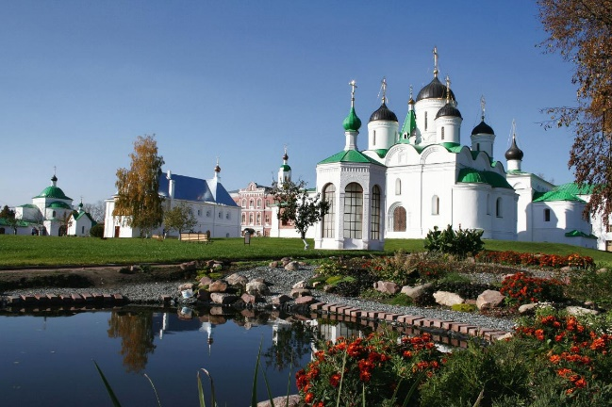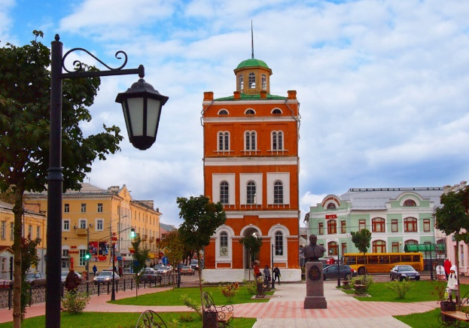
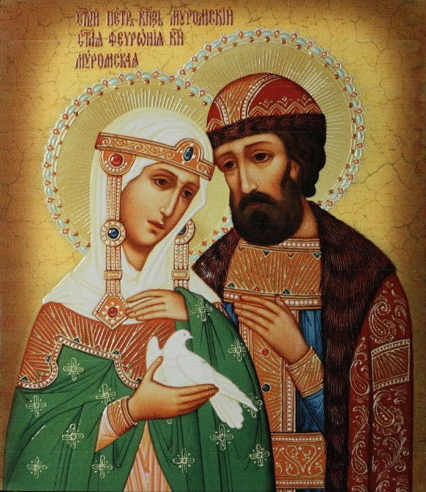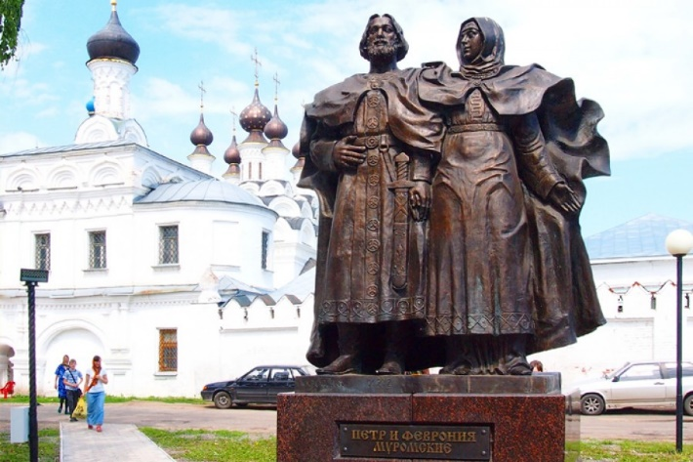
Task 2. Read the text and choose the best title.
1. The Saints Peter and Fevronia
2. The Saints Peter and Fevronia: Symbols of Love and Fidelity
3. An Unusual Legend
4. The History of Murom
5. The Day of Family, Love and Faithfulness
Task 3. Read the text again and mark the sentences true (T), false (F) or not stated (NS)
1. The tale of the saints` life and love dates back to the 15th century.
2. The symbol of July 8th is considered to be a daisy.
3. Peter didn`t promise to marry Fevronia.
4. Peter was strong enough to cure by himself.
5. People of different ages pray to Peter and Fevronia for great love and ask them for harmony in families.
Task 4. Complete the sentences from the text
1. The saints Peter and Fevronia are the patrons…
2. Fevronia knew the properties of…
3. The nobles respected Peter, but…
4. Peter chose to go with…
5. In spite of their will they were buried in…
Task 5. Write the following sentences in Past Simple.
- The saints Peter and Fevronia are the patrons of marriage and family.
- Peter is very ill and nobody can help him.
- She knows the properties of herbs.
- Peter falls in love with the girl.
- He inherits the throne.
- The duke marries Fevronia.
- Their proud wives don`t like Fevronia because she is nice.
- The nobles make the duke leave her.
- Peter chooses to stay with his lovely wife.
- They rule long and happily.
Task 6. Put the verbs in the right column.
Was, promised, fell in love, went, knew, inherited, kept, chose, asked, ruled, tried, found, wished, married.
Regular Verbs (Правильные глаголы) | Irregular Verbs (Неправильные глаголы )
Пообещал- | Ходил-
Унаследовал- | Знал-
Управлял- | Влюбился-
Попросил- | Выбрал-
Пытался- | Хранился-
Желали- | Нашел-
Женился- | Был-

Task 7. Tell your classmates about any holiday/ a story that is similar to the story of Peter and Fevronia. The following plan is sure to help you.
The name of the holiday
Date
Main characters
The history of the holiday
Symbols
Traditions
I like/don’t like this holiday because …….

Keys
Task2
The Saints Peter and Fevronia: Symbols of Love and Fidelity
Task3
1. The tale of the saints` life and love dates back to the 15th century.(F)
2. The symbol of July 8th is considered to be a daisy.(NS)
3. Peter didn`t promise to marry Fevronia. (F)
4. Peter was strong enough to cure by himself.(F)
5. People of different ages pray to Peter and Fevronia for great love and ask them for harmony in families.(T)
Task4
1. The saints Peter and Fevronia are the patrons of marriage and family, and the symbols of love and fidelity.
2. Fevronia knew the properties of herbs and could treat people.
3. The nobles respected Peter, but their arrogant wives didn’t like Fevronia because she was pleasant.
4. Peter chose to go with his beloved wife in exile, leaving Murom.
5. In spite of their will they were buried in different places, but next day people found their bodies in the same grave.
Task5
- The saints Peter and Fevronia were the patrons of marriage and family.
- Peter was very ill and nobody could help him.
- She knew the properties of herbs.
- Peter fell in love with the girl.
- He inherited the throne.
- The duke married Fevronia.
- Their proud wives didn`t like Fevronia because she was nice.
- The nobles made the duke leave her.
- Peter chose to stay with his lovely wife.
10)They ruled long and happily.

Task6
Regular Verbs (Правильные глаголы) | Irregular Verbs (Неправильные глаголы )
Пообещал- promised | Ходил- went
Унаследовал- inherited | Знал- knew
Управлял- ruled | Влюбился- fell in love
Попросил- asked | Выбрал- chose
Пытался-tried | Хранился- kept
Желали- wished | Нашел- found
Женился- married | Был- was

